# **Sir Syed University of Engineering & Technology (SSUET)**



# **Computer Engineering Department**

***Course Name: OBJECT ORIENTED PROGRAMMING (CE-225L)***

***Semester:4TH***

***Batch: 2021F***

***Section: B***

**PROJECT REPORT**

***Project Title: School Registry Management System***

|  |  |
| --- | --- |
| **Name** | **Roll Number** |
| **RIJA JAVED** | **2021F-BCE-059** |
| **INSHARA AHMED** | **2021F-BCE-065** |
| **MUHAMMAD KHALIL ASHRAF(GL)** | **2021F-BCE-199** |

***Submitted To:***

***Samina Noureen***

***ACKNOWLEDGEMENT***

It’s an honor for me to express our special gratitude towards Samina Noureen

, for his constant efforts, Suggestions, Guidance, and helping us whenever we needed it the most and also be an inspiration for us to constantly work hard for our goals without which it would be difficult to complete it and understood the subject within the given time. We are also thankful to all the team worked in the back, especially to the head of the department, Computer Engineering, Sir Syed University for making it all possible and permitting us to continue the project. While having the opportunity we would also like to thank all the respective teacher of the department for their efforts, and being a source of inspiration and motivation to work and showing us the right way to achieve the maximum in life ahead.



**Sir Syed University of Engineering & Technology, Karachi**

**Computer Engineering Department**

***Rubric Guideline for Project***

*Course Name (Course Code),**CE-225L Semester 4th, Batch 2021F*

***Name of Student:*** *Muhammad Khalil Ashraf* ***Roll No.*** *2021F-BCE-199*

|  |  |  |  |  |  |
| --- | --- | --- | --- | --- | --- |
| **Criteria** | **Exceeds Expectations (>=90%)** | **Meets Expectations (70%-89%)** | **Developing**  **(50%-69%)** | **Unsatisfactory (<50%)** | **Score Obtained** |
| **Project Demonstration** | Able to demonstrate the project with achievement of required objectives having clear understanding of project limitations and future enhancements. Hardware and/or Software modules are fully functional, if applicable. | Able to demonstrate the project with achievement of required objectives but understanding of project limitations and future enhancements is insufficient. Hardware and/or Software modules are functional, if applicable. | Able to demonstrate the project with achievement of a*t least 50% required objectives and insufficient understanding of project limitations and future enhancements. Hardware and/or Software modules are partially functional, if applicable. | Able to demonstrate the project with achievement of less than 50% required objectives and lacks in understanding of project limitations and future enhancements. Hardware and/or Software modules are not functional, if applicable. |  |
| **Project results** | Able to achieve all the desired results with alternate ways to improve measurements | Able to achieve all the desired results | Able to achieve most of the desired results with errors | Unable to achieve the desired results |  |
| **Project Report** | Project report has no grammatical and/ or spelling errors.  All sections of the report are very well-written and technically accurate. | Project report has very few grammatical/ spelling errors.  All sections of the report are technically accurate. | Project report has multiple grammatical/ spelling errors.  Few sections of the report contains technical errors. | Project report has several grammatical/ spelling errors and sentence construction is poor. |  |
| **Viva** | Able to answer the questions easily and correctly across the project. | Able to answer the questions related to the project | Able to answer the questions but with mistakes | Unable to answer the questions |  |
| **Total Marks** | | | | |  |

**Sir Syed University of Engineering & Technology, Karachi**

**Computer Engineering Department**

***Rubric Guideline for Project***

*Course Name (Course Code),**CE-225L Semester 4th, Batch 2021F*

***Name of Student:*** *Inshara Ahmed* ***Roll No.*** *2021F-BCE-065*

|  |  |  |  |  |  |
| --- | --- | --- | --- | --- | --- |
| **Criteria** | **Exceeds Expectations (>=90%)** | **Meets Expectations (70%-89%)** | **Developing**  **(50%-69%)** | **Unsatisfactory (<50%)** | **Score Obtained** |
| **Project Demonstration** | Able to demonstrate the project with achievement of required objectives having clear understanding of project limitations and future enhancements. Hardware and/or Software modules are fully functional, if applicable. | Able to demonstrate the project with achievement of required objectives but understanding of project limitations and future enhancements is insufficient. Hardware and/or Software modules are functional, if applicable. | Able to demonstrate the project with achievement of a*t least 50% required objectives and insufficient understanding of project limitations and future enhancements. Hardware and/or Software modules are partially functional, if applicable. | Able to demonstrate the project with achievement of less than 50% required objectives and lacks in understanding of project limitations and future enhancements. Hardware and/or Software modules are not functional, if applicable. |  |
| **Project results** | Able to achieve all the desired results with alternate ways to improve measurements | Able to achieve all the desired results | Able to achieve most of the desired results with errors | Unable to achieve the desired results |  |
| **Project Report** | Project report has no grammatical and/ or spelling errors.  All sections of the report are very well-written and technically accurate. | Project report has very few grammatical/ spelling errors.  All sections of the report are technically accurate. | Project report has multiple grammatical/ spelling errors.  Few sections of the report contains technical errors. | Project report has several grammatical/ spelling errors and sentence construction is poor. |  |
| **Viva** | Able to answer the questions easily and correctly across the project. | Able to answer the questions related to the project | Able to answer the questions but with mistakes | Unable to answer the questions |  |
| **Total Marks** | | | | |  |

**Sir Syed University of Engineering & Technology, Karachi**

**Computer Engineering Department**

***Rubric Guideline for Project***

*Course Name (Course Code),**CE-225L Semester4th, Batch 2021F*

***Name of Student:*** *Rija Javed* ***Roll No.*** *2021F-BCE-059*

|  |  |  |  |  |  |
| --- | --- | --- | --- | --- | --- |
| **Criteria** | **Exceeds Expectations (>=90%)** | **Meets Expectations (70%-89%)** | **Developing**  **(50%-69%)** | **Unsatisfactory (<50%)** | **Score Obtained** |
| **Project Demonstration** | Able to demonstrate the project with achievement of required objectives having clear understanding of project limitations and future enhancements. Hardware and/or Software modules are fully functional, if applicable. | Able to demonstrate the project with achievement of required objectives but understanding of project limitations and future enhancements is insufficient. Hardware and/or Software modules are functional, if applicable. | Able to demonstrate the project with achievement of a*t least 50% required objectives and insufficient understanding of project limitations and future enhancements. Hardware and/or Software modules are partially functional, if applicable. | Able to demonstrate the project with achievement of less than 50% required objectives and lacks in understanding of project limitations and future enhancements. Hardware and/or Software modules are not functional, if applicable. |  |
| **Project results** | Able to achieve all the desired results with alternate ways to improve measurements | Able to achieve all the desired results | Able to achieve most of the desired results with errors | Unable to achieve the desired results |  |
| **Project Report** | Project report has no grammatical and/ or spelling errors.  All sections of the report are very well-written and technically accurate. | Project report has very few grammatical/ spelling errors.  All sections of the report are technically accurate. | Project report has multiple grammatical/ spelling errors.  Few sections of the report contains technical errors. | Project report has several grammatical/ spelling errors and sentence construction is poor. |  |
| **Viva** | Able to answer the questions easily and correctly across the project. | Able to answer the questions related to the project | Able to answer the questions but with mistakes | Unable to answer the questions |  |
| **Total Marks** | | | | |  |

**TABLE OF CONTENTS**

|  |  |  |
| --- | --- | --- |
| 1 | Introduction | 9pg |
| 2 | Project description | 9pg |
| 3 | Data Flow Diagram | 10pg |
| 4 | Algorithm | 11pg |
| 5 | Results | 14pg |
| 6 | Conclusion | 14pg |

TEAM PROFILE

* **Syed Muzaffar Raza (2021F-BCE - 057)**

(Program Researcher)

* **RIJA JAVED (2021F-BCE-059)**

(Coding of Program, Maker of Presentation)

* **INSHARA AHMED (2021F-BCE -065)**

(Coding of Program, Maker of Project Report, Maker of Presentation)

* **MUHAMMAD KHALIL ASHRAF (2021F-BCE-199)**

(Program Prototype, Design and Coding of Program, Data Structure)

## 1. Introduction

In the ever-evolving world of education, managing student and teacher information efficiently is crucial for schools and educational institutions. To streamline administrative processes and enhance data management, the implementation of a comprehensive School Registry System has become essential. This system serves as a centralized database where schools can register and store information about students and teachers, providing easy access to pertinent data when needed.

The School Registry System offers numerous advantages over traditional paper-based methods of record-keeping. By digitizing the registration process, schools can significantly reduce paperwork, minimize errors, and improve data accuracy. Additionally, this system enables administrators to streamline their workflow, allowing them to focus more on essential tasks that contribute to the overall growth and development of the educational institution.

Key Features of the School Registry System:

**Student Registration:** The system facilitates the seamless registration of students, capturing vital information such as personal details, contact information, academic records, and medical history. This data can be easily updated and maintained throughout a student's educational journey, providing a comprehensive profile for effective monitoring and evaluation.

**Teacher Registration:** The School Registry System also allows for the efficient registration and management of teachers. It enables administrators to record essential details like qualifications, contact information, employment history, and subject expertise. This information is crucial for assigning classes, tracking professional development, and evaluating teaching performance.

**Database Management:** The system acts as a centralized database, securely storing all student and teacher information. Authorized personnel, such as administrators and designated staff members, can access and update the database as required. This ensures data integrity, privacy, and the ability to generate accurate reports and statistics whenever necessary.

**Data Accessibility:** The School Registry System offers a user-friendly interface that allows authorized personnel to access the database easily. Administrators, teachers, and other relevant stakeholders can view student and teacher records, generate reports, and extract data for analysis or decision-making purposes. This real-time access to information enhances transparency and enables timely interventions when needed.

**Communication and Collaboration:** The system can incorporate communication features, such as messaging or email integration, to facilitate efficient interaction between administrators, teachers, and parents. This helps in fostering effective communication channels, sharing important updates, and ensuring the seamless flow of information among stakeholders.

## 2. Project description

The School Registry System is a centralized database that allows schools to register and store student and teacher information. It simplifies administrative processes by digitizing registration and reducing paperwork. The system captures and maintains crucial details such as personal information, contact details, academic records, and medical history for students. For teachers, it records qualifications, employment history, and subject expertise. Authorized personnel can access and update the database, ensuring data integrity and privacy. The system offers real-time access to information, enabling stakeholders to generate reports, analyze data, and make informed decisions.

## 3. Output

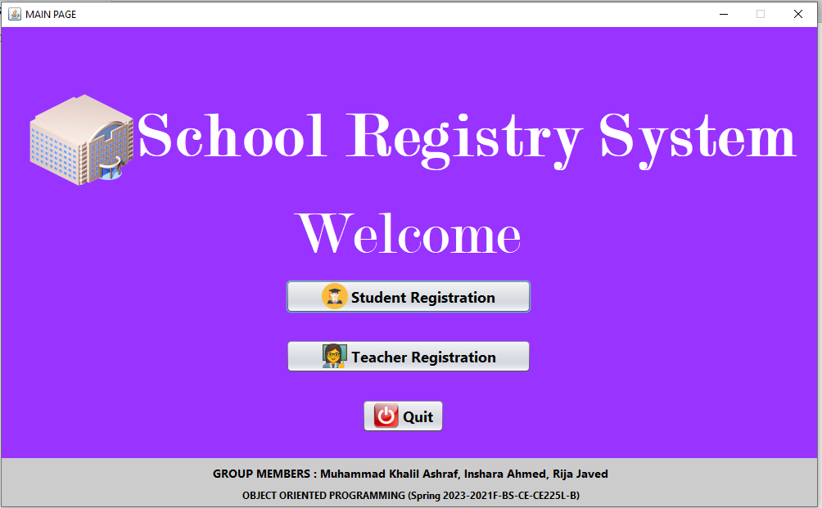 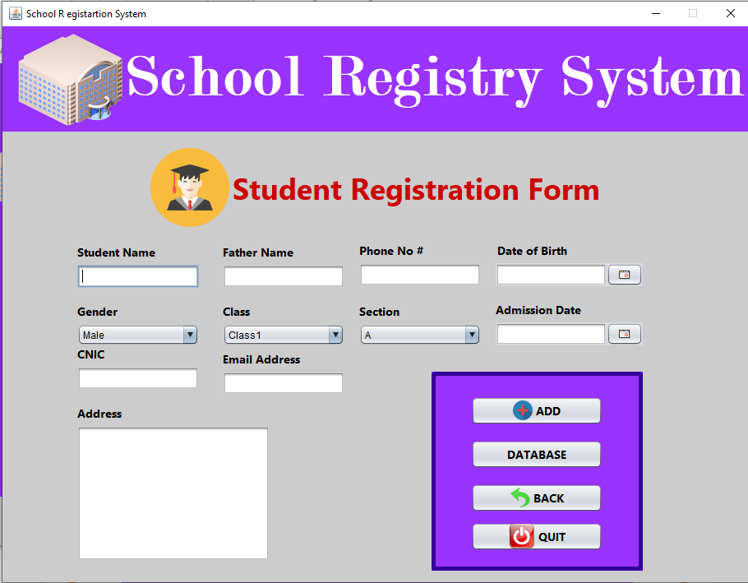 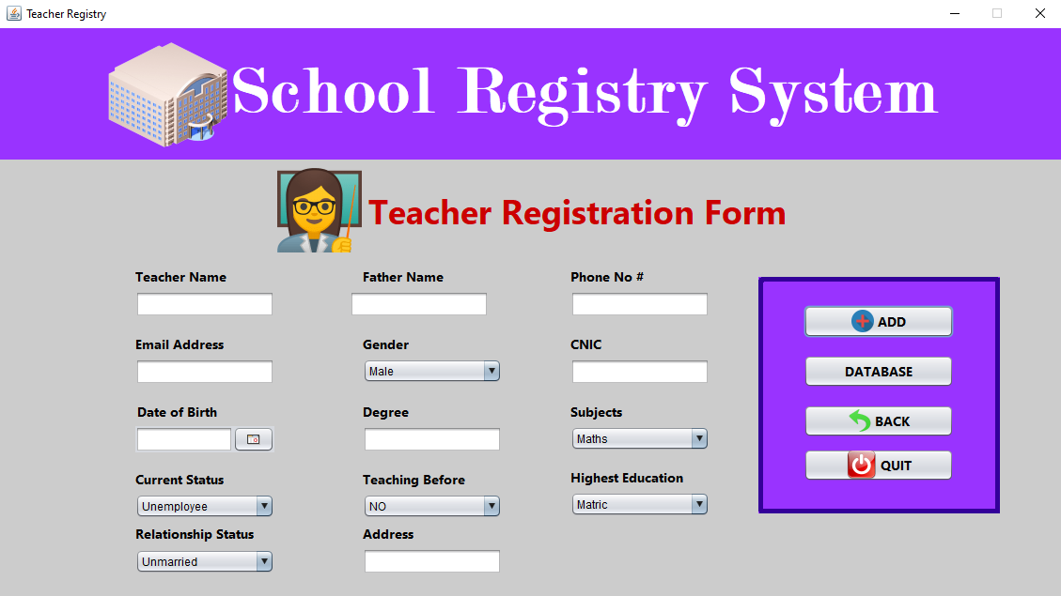 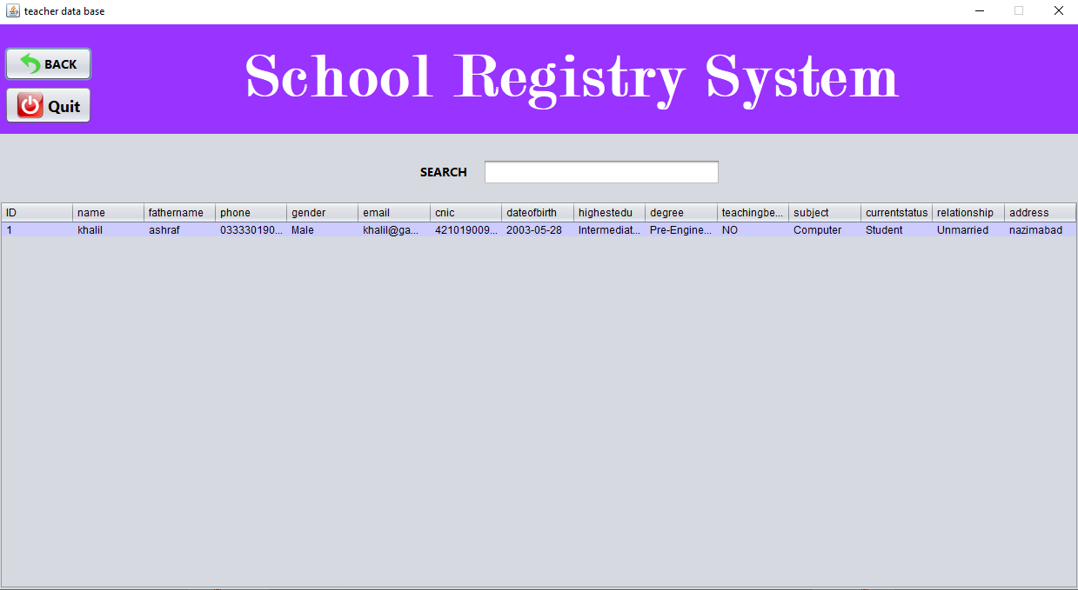

## 4. Code

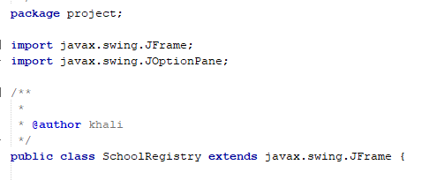

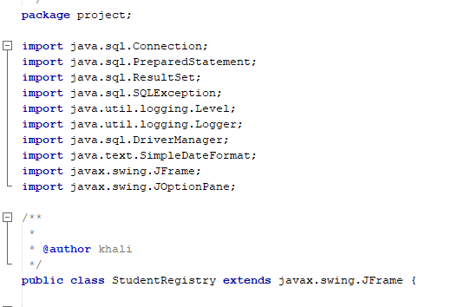

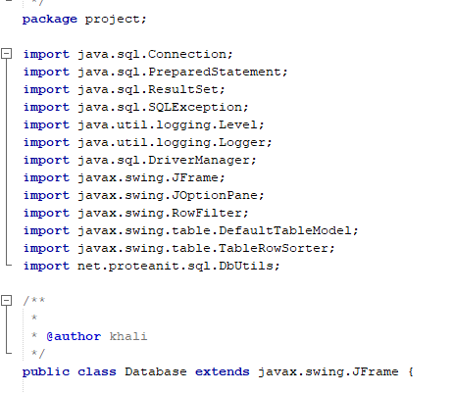

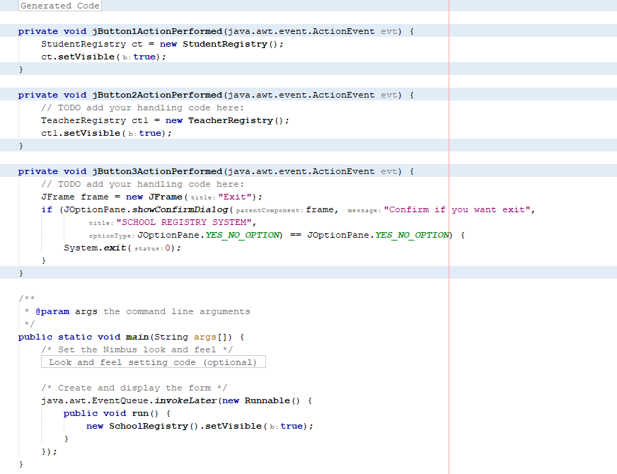 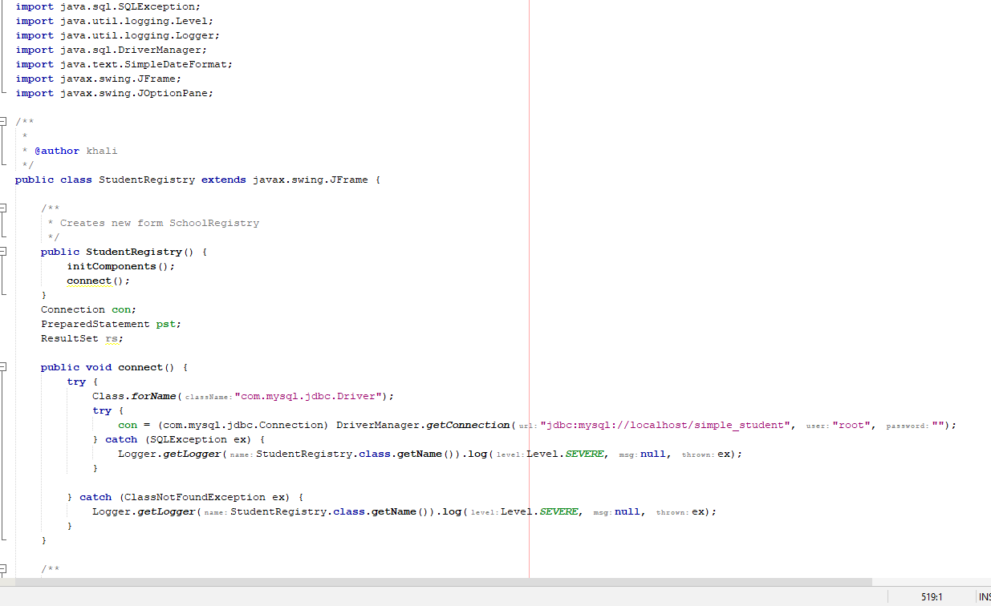 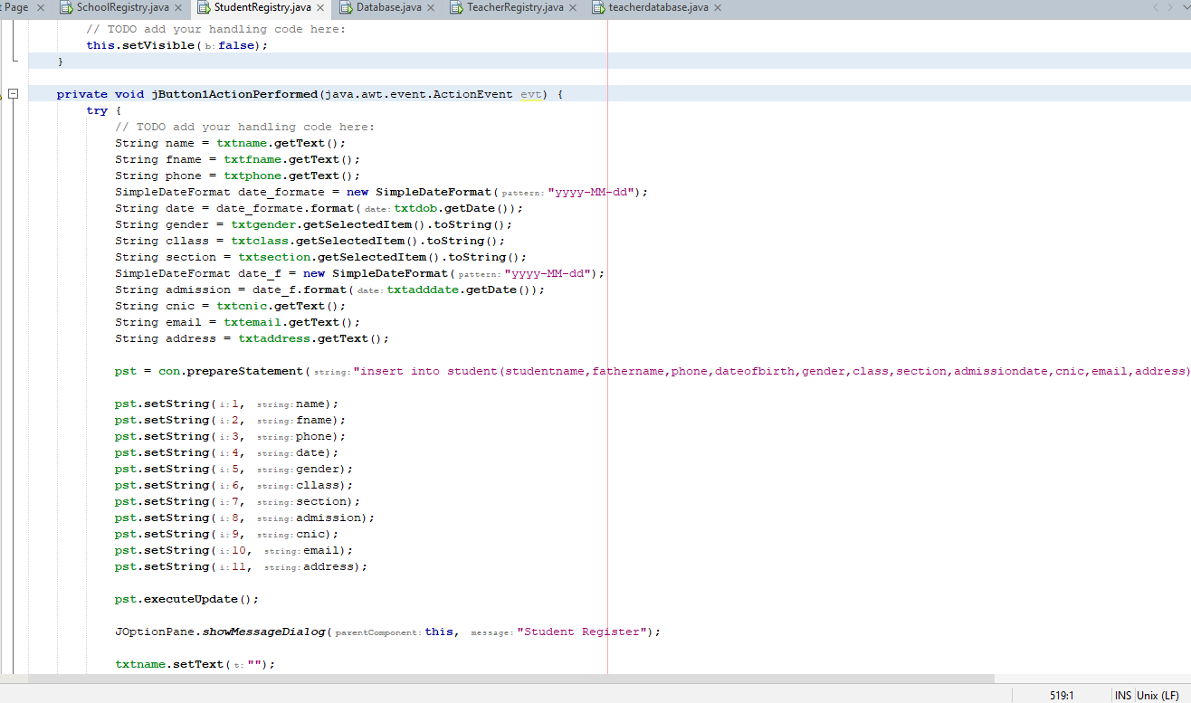 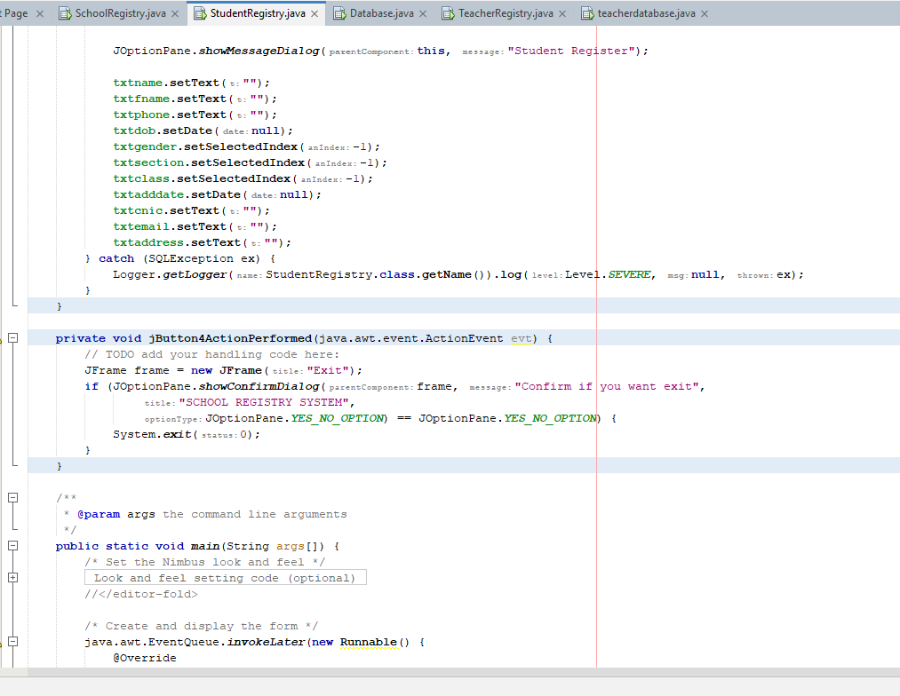 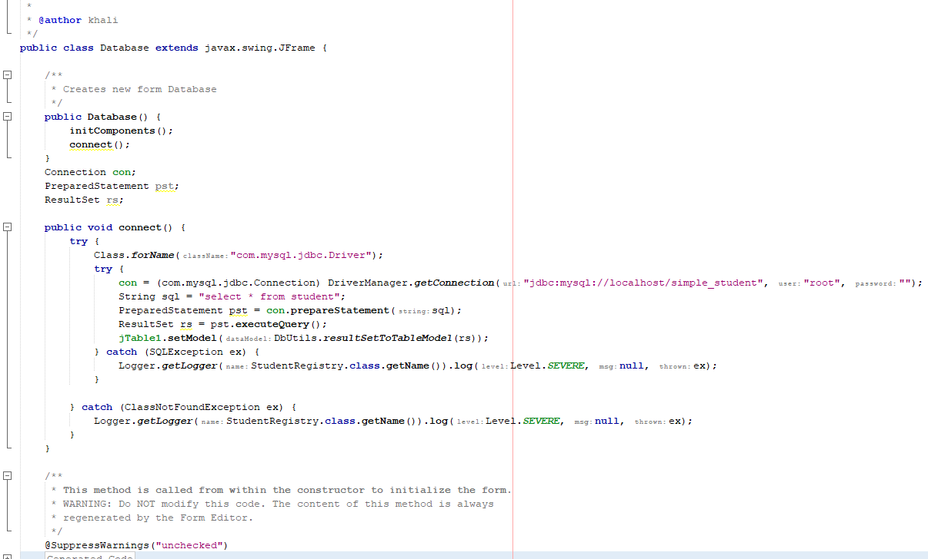 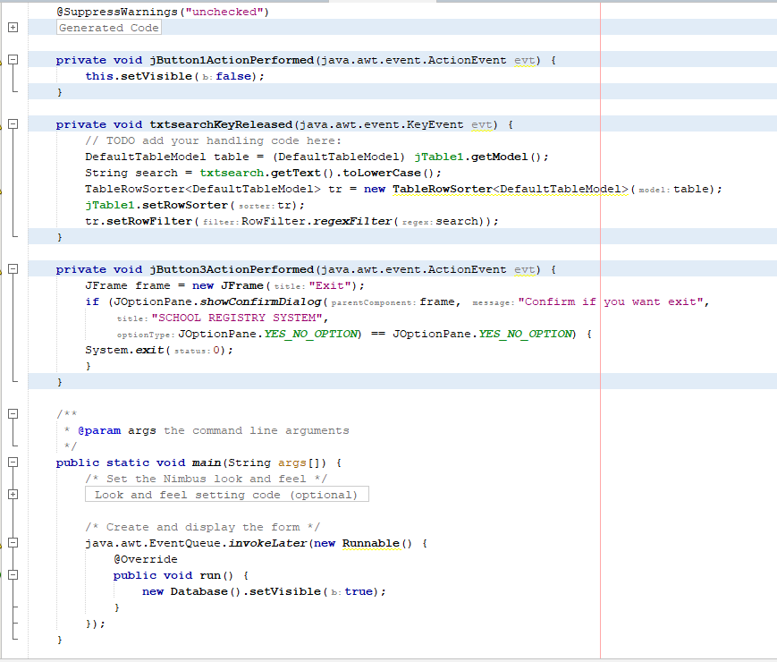

## 5. Reasons for choosing the project

**Streamlined Administrative Processes:** By digitizing the registration process and centralizing data management, the School Registry System eliminates the need for manual paperwork and reduces administrative burden. This allows staff members to allocate their time and resources more efficiently, focusing on other critical tasks.

**Enhanced Data Accuracy and Integrity:** With a School Registry System, the chances of errors and inconsistencies in student and teacher records are significantly reduced. The system ensures that accurate and up-to-date information is captured and maintained, providing a reliable database for decision-making, reporting, and analysis.

**Improved Accessibility and Efficiency:** The system provides authorized personnel with easy access to student and teacher information anytime, anywhere. This accessibility promotes efficient communication and collaboration among stakeholders, facilitating timely interventions and fostering a more productive educational environment.

**Data Security and Privacy:** The School Registry System offers enhanced security measures to protect sensitive student and teacher information. It ensures that only authorized individuals can access and modify the database, maintaining data privacy and complying with relevant data protection regulations.

**Data Analysis and Reporting Capabilities:** With a centralized database, the School Registry System enables schools to generate comprehensive reports and extract valuable insights from the data. This facilitates data-driven decision-making, enables performance tracking, and supports the implementation of effective educational strategies.

**Scalability and Adaptability:** The School Registry System can be designed to accommodate the specific needs and requirements of different educational institutions. It can be easily scaled up or adapted to future changes, ensuring long-term usability and effectiveness.

## 6. Conclusion

In conclusion, the implementation of a School Registry System offers significant advantages for educational institutions. By digitizing and centralizing student and teacher information, schools can streamline administrative processes, enhance data accuracy, improve accessibility, and strengthen data security. The system promotes efficient communication and collaboration among stakeholders, enables data-driven decision-making, and supports the implementation of effective educational strategies. With its scalability and adaptability, the School Registry System provides a long-term solution to meet the evolving needs of educational institutions. By choosing to implement this project, schools can optimize their data management practices, ultimately fostering a more efficient and productive learning environment for students and teachers alike.